***Micro Service : The service which is responsible to do small task, develop using same language or different language with same database or different database and deploy that application using jar or war file independently.***

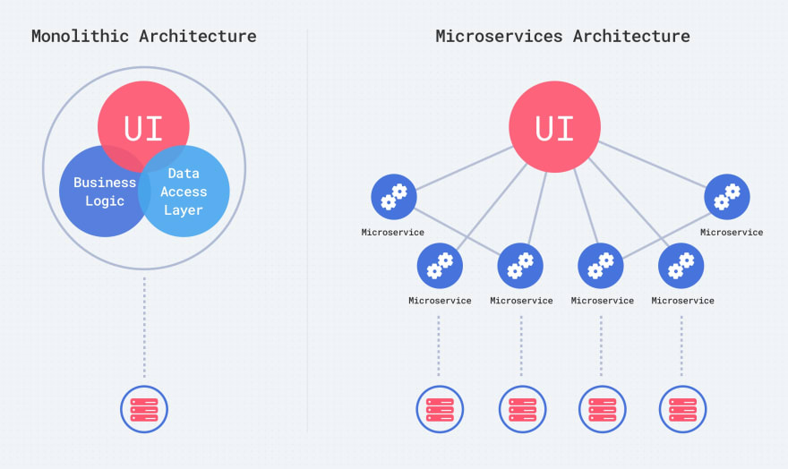

***In monolithic web service :***

***Login module -🡪 controller, entity, service and repository , database***

***Customer module 🡪 controller, entity, service and repository, database***

***Manager module***

***Account module***

***Product module***

***Order module***

***Dev1***

***Dev2 shared repository-----🡪 CI and CD (Continuous Integration***

***Dev3 Continuous Deployment or Delivery***

***Jenkin tool.***

***Build the project, compile the program, run the program, create the jar or war file.***

***In this architecture we combine all modules and create one jar or war file and deploy whole application on production environment.***

***In this style all modules develop using same language with same database.***

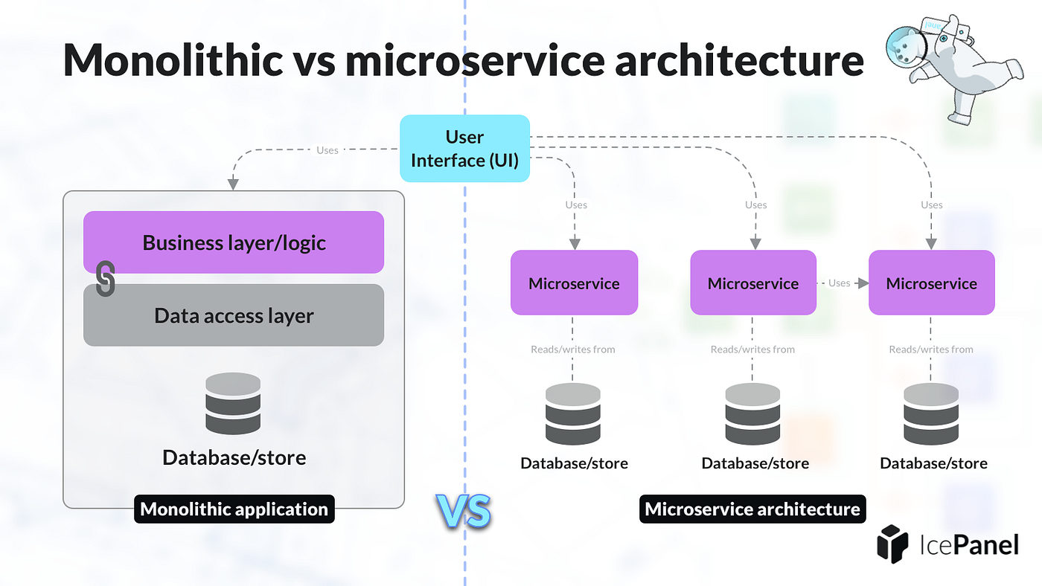

***To implements micro service concept in Spring boot. Spring boot provided two modules.***

***Spring cloud***

***Spring micro service with eureka server***

***Spring boot provided one of the open source server Eureka Server part or Netflix stack. Eureka server responsible to deploy more than one micro service project, it provide service details like hostname, port number and service specific information.***

1. ***We need to create the Eureka Server.***

***Using spring initializer***

***Starter -🡪 Web***

***Starter 🡪Eureka Server***

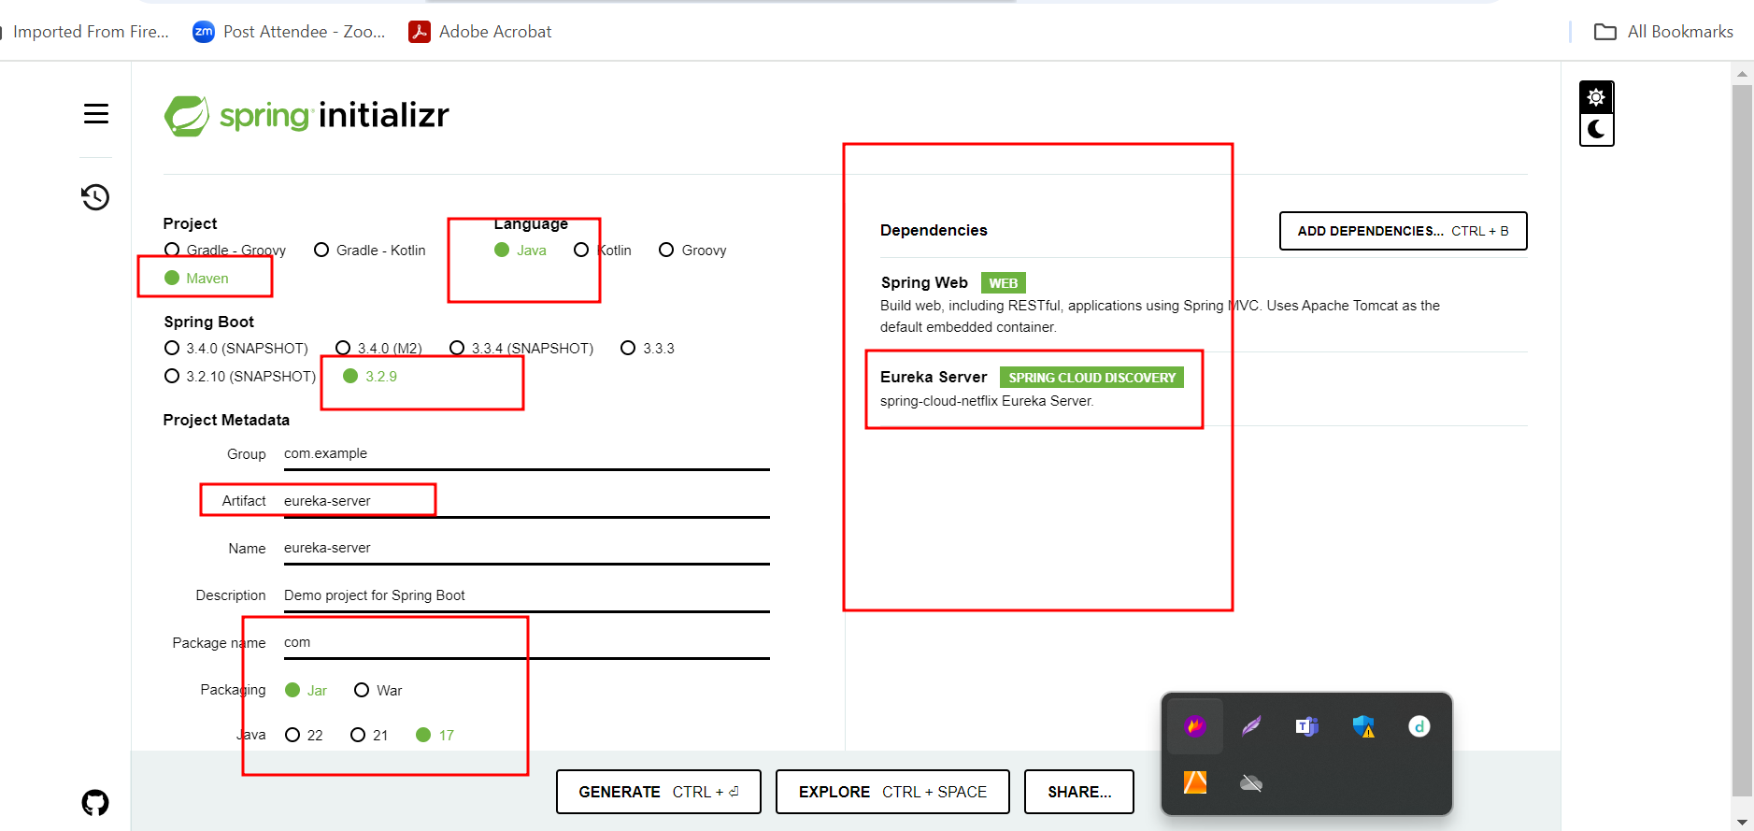

***Whenever we deploy micro service client application by default each micro service project search eureka server on default port number 8761***

***Inside this project in application.properties file add 3 line code***

***spring.application.name=eureka-server***

***server.port=8761***

***eureka.client.register-with-eureka=false***

***eureka.client.fetch-registry=false***

***please use @EnableEurekaServer annotation to enable eureka server.***

1. ***first-micro-service-client : this project responsible to create simple rest api***

***starter -🡪Web Starter***

***starter 🡪Eureka Discovery client***

